CALL DISTRIBUTION IN CALL CENTER

**Introduction:**

A call center is a centralized office or facility that is equipped to handle large amounts of customer telephone requests for an organization. A call handles all telephone communications with new and existing customers. Each server can attain call of customers for 10 minutes and if a server is busy while serving a customer it holds customers calls in waiting list. It also stores the calling information of customer’s call.

**Solution Method:**

Our project we use multiple servers that will solve different problem over the phone. In our project we use many concepts of **Data Structure**.

We used **linked list** for constructing multiple server and storing customer’s information. For each server each call history is saved in a **stack**. We also used **queue** for holding customers call in waiting list. Here, **Pointer** is used foe allocating memory and pointing different locations. We also used **structure** for constructing linked list.

**Algorithm:**

In this project we used different types of algorithms. These are;

1. Create ‘n’ number of servers.
2. Make a call on server.
3. Check if ‘server 1’ is available. If isn’t, forward the call to the remaining server. If all the server is busy, hold the call in the waiting list in queue.
4. After getting service save the caller information in the database in stack and check waiting list for receiving call. If any customers take more than 10 min send him/her call in the waiting list.
5. If waiting list is empty then it will wait for a call.
6. Repeat step 2 again.

**Output:**

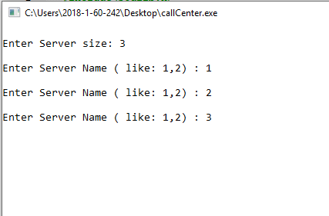 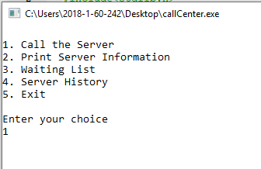

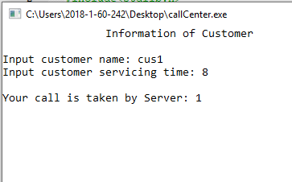 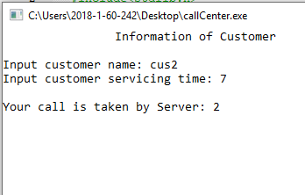

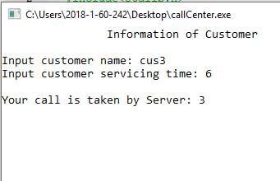 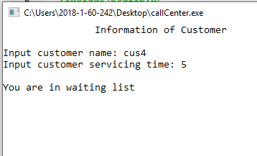

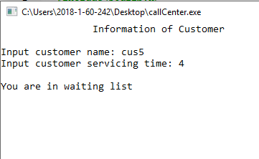 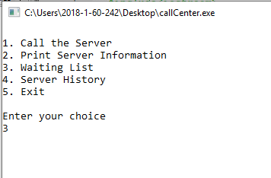

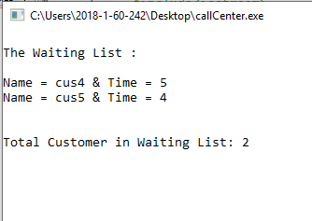 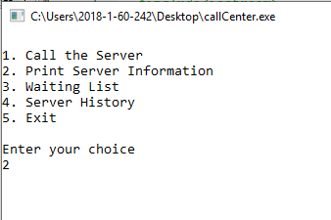

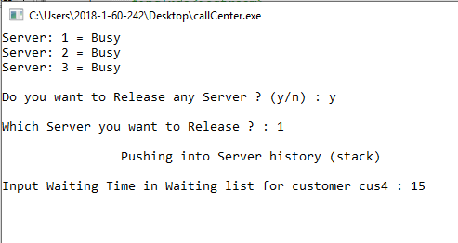 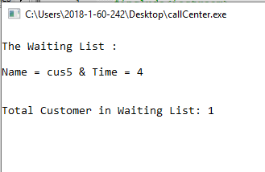

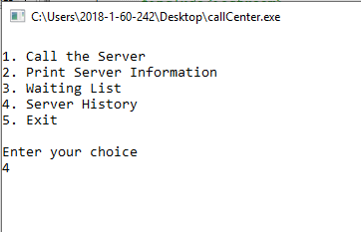 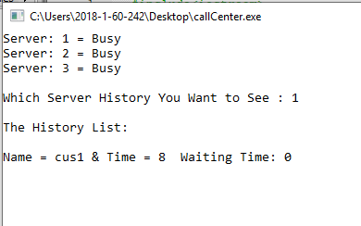

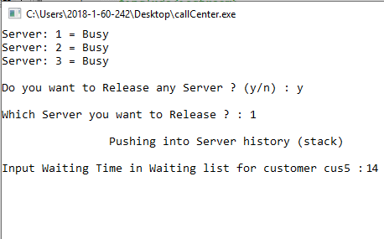 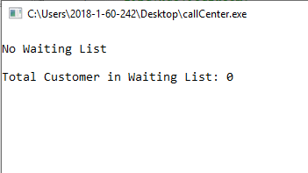

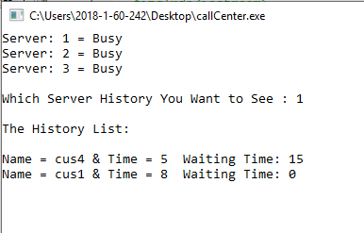

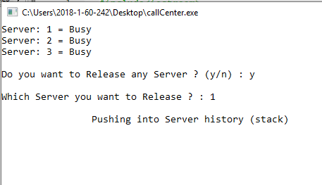

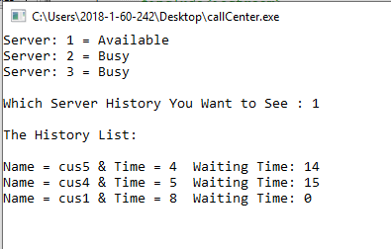 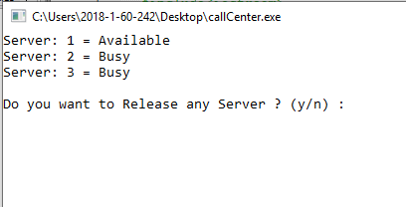

**Summary:**

It includes total calls answered, time of session, time spent on active calls, time spent waiting for calls, and time spent entering call notes and unavailable for new calls. A call center has an open workspace for call center agents, with work stations that include a computer and display for each agent, a telephone set connected to a telecom switch or to an inbound/outbound call management system, and one or more supervisor stations. In this project we did not use time function here we set time manually. In future we can used time function for making this project more efficient. In future we can link this software to the mobile/telephone for real life software.